3. Arumetsa Clay
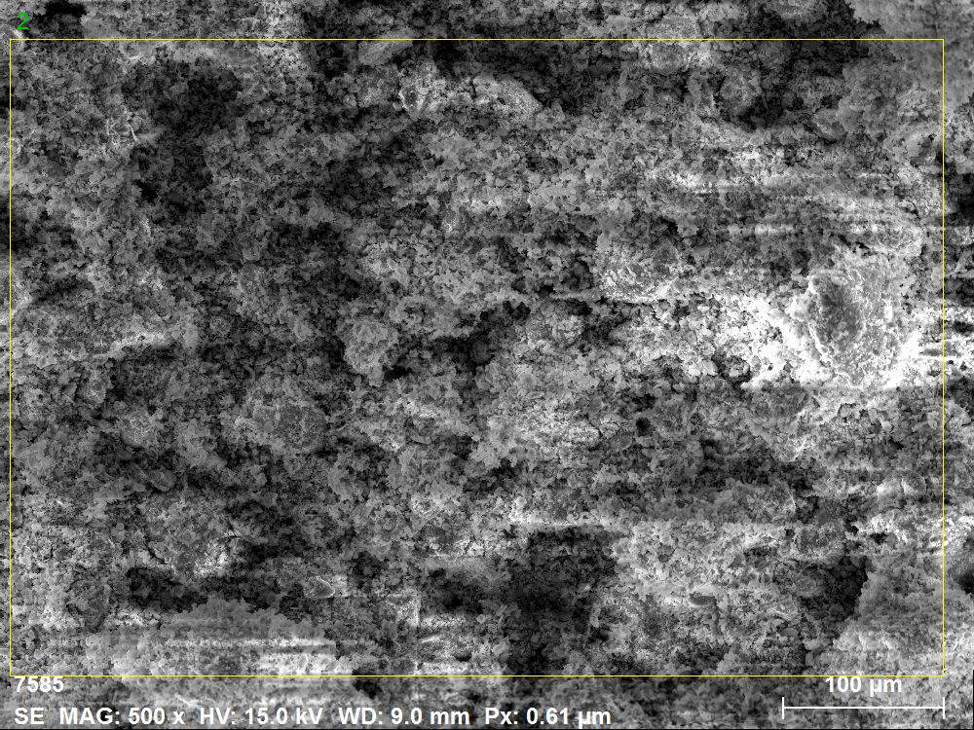

Spectrum: 2
Element Series unn. C norm. C Atom. C Error (1 Sigma)
[wt.%] [wt.%] [at.%] [wt.%]
---------------------------------------------------------
Iron K-series 6.15 7.15 2.77 0.21
Titanium K-series 0.66 0.77 0.35 0.05
Calcium K-series 0.95 1.10 0.60 0.05
Potassium K-series 4.37 5.08 2.81 0.16
Silicon K-series 22.27 25.88 19.95 0.95
Aluminium K-series 10.35 12.03 9.65 0.50
Magnesium K-series 1.55 1.80 1.60 0.11
Sodium K-series 0.45 0.52 0.49 0.05
Oxygen K-series 39.30 45.67 61.79 4.23
---------------------------------------------------------
Total: 86.05 100.00 100.00

4. Ligniin
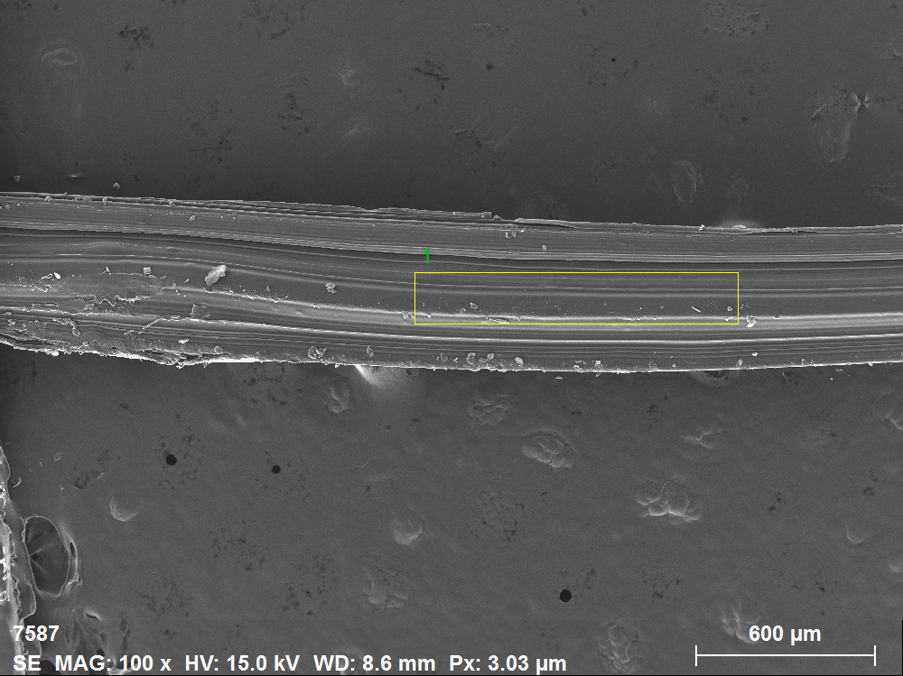

Spectrum: 1
Element Series unn. C norm. C Atom. C Error (1 Sigma)
[wt.%] [wt.%] [at.%] [wt.%]
---------------------------------------------------------
Chlorine K-series 9.06 9.06 3.58 0.33
Sulfur K-series 0.64 0.64 0.28 0.05
Oxygen K-series 22.38 22.38 19.61 2.73
Nitrogen K-series 15.88 15.88 15.89 2.21
Carbon K-series 51.90 51.90 60.57 5.85
Silicon K-series 0.08 0.08 0.04 0.03
Aluminium K-series 0.06 0.06 0.03 0.03
---------------------------------------------------------
Total: 100.00 100.00 100.00

5. Lamb
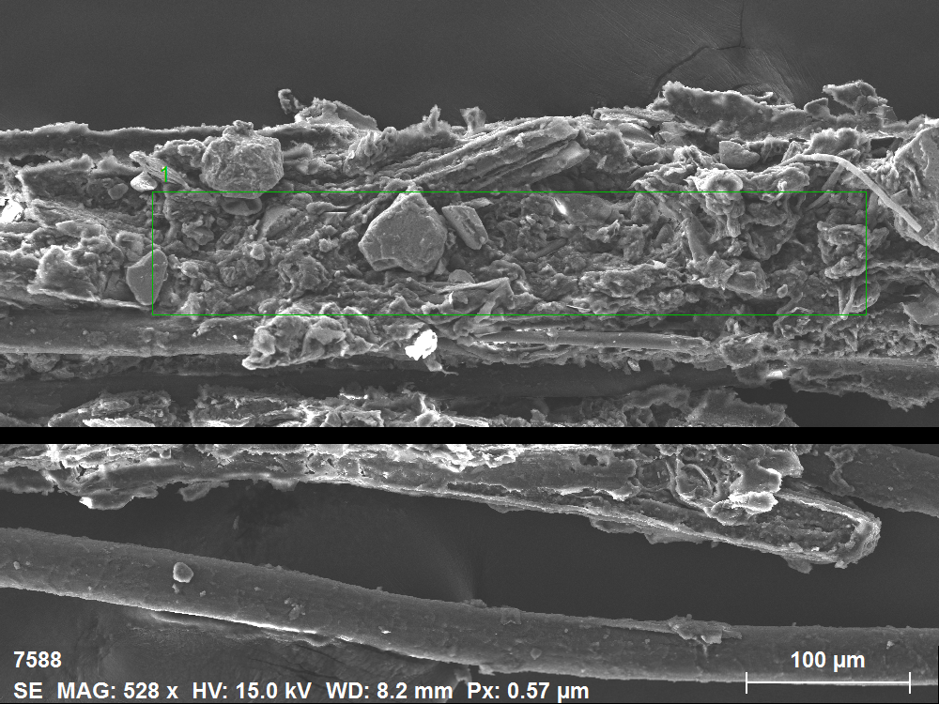

Spectrum: 1

Element Series unn. C norm. C Atom. C Error (1 Sigma)
[wt.%] [wt.%] [at.%] [wt.%]
----------------------------------------------------------
Iron K-series 0.49 0.58 0.16 0.05
Calcium K-series 1.96 2.32 0.88 0.09
Potassium K-series 5.62 6.65 2.60 0.20
Chlorine K-series 0.28 0.33 0.14 0.04
Sulfur K-series 0.50 0.59 0.28 0.04
Phosphorus K-series 0.44 0.53 0.26 0.04
Silicon K-series 5.22 6.17 3.36 0.24
Aluminium K-series 1.14 1.35 0.77 0.08
Magnesium K-series 0.33 0.39 0.25 0.04
Sodium K-series 0.90 1.06 0.71 0.08
Oxygen K-series 29.58 34.97 33.46 3.49
Nitrogen K-series 1.51 1.78 1.95 0.37
Carbon K-series 36.62 43.29 55.18 4.20
----------------------------------------------------------
Total: 84.60 100.00 100.00

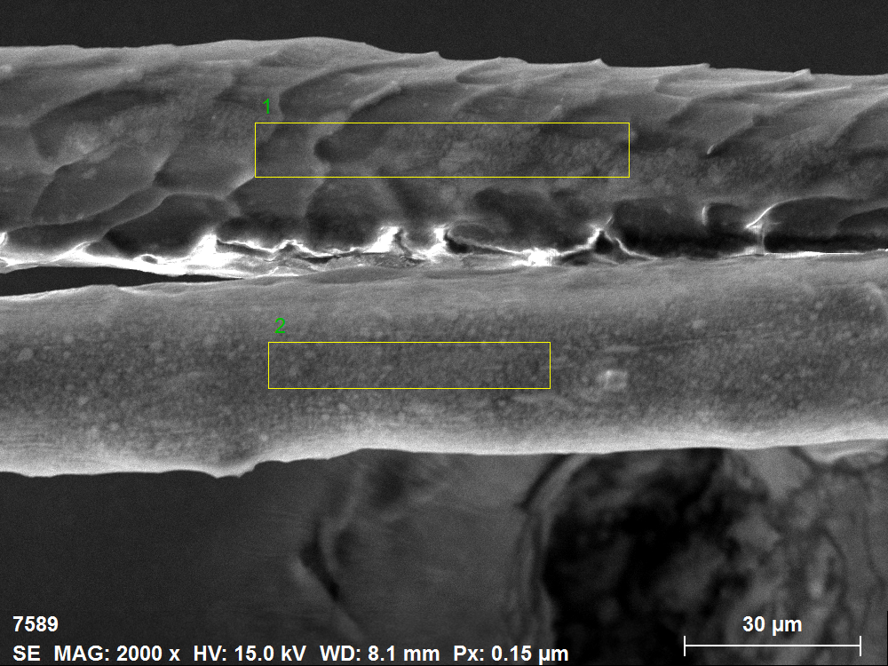

Spectrum: 1
Element Series unn. C norm. C Atom. C Error (1 Sigma)
[wt.%] [wt.%] [at.%] [wt.%]
---------------------------------------------------------
Potassium K-series 4.21 4.21 1.50 0.16
Chlorine K-series 0.29 0.29 0.11 0.04
Sulfur K-series 2.43 2.43 1.05 0.11
Sodium K-series 0.28 0.28 0.17 0.04
Oxygen K-series 28.97 28.97 25.20 3.44
Nitrogen K-series 12.03 12.03 11.96 1.75
Carbon K-series 51.79 51.79 60.01 5.70
---------------------------------------------------------
Total: 100.00 100.00 100.00

Spectrum: 2
Element Series unn. C norm. C Atom. C Error (1 Sigma)
[wt.%] [wt.%] [at.%] [wt.%]
---------------------------------------------------------
Calcium K-series 0.25 0.31 0.12 0.04
Potassium K-series 16.11 19.70 7.71 0.52
Chlorine K-series 0.12 0.15 0.07 0.03
Sulfur K-series 0.90 1.10 0.52 0.06
Sodium K-series 0.65 0.79 0.53 0.07
Oxygen K-series 21.09 25.78 24.67 2.64
Nitrogen K-series 0.00 0.00 0.00 0.00
Carbon K-series 42.53 52.00 66.28 4.75
Silicon K-series 0.07 0.09 0.05 0.03
Aluminium K-series 0.01 0.02 0.01 0.03
Magnesium K-series 0.06 0.07 0.04 0.03
---------------------------------------------------------
Total: 81.80 100.00 100.00

